**Shop Inventory Management System User Guide**

# Overview

Welcome to the Shop Inventory Management System! With this system, you will be able to create, update, and delete parts and products in the inventory system.

There are two types of parts to work with:

* Inhouse Parts – These are made in our shop. Each of these parts will have an assigned part id.
* Outsourced Parts – These are purchased from outside vendors. Each will have a Company name.

There are also products, which are created and then assembled with specified parts from the shop inventory.

Parts and Products are identified by Name, Price, and Available Inventory Count (aka “Number in Stock”). Controls are in place to make sure the sum-total of the prices of the specified parts do not exceed the price of the product that contains them.

When a product’s available inventory count is increased, the inventory count of the Parts that are associated with the product will reflect the change in a decrease in those parts’ available inventory count. Once a product is assembled it cannot be disassembled.

# Getting Started

To get started, open your application in the lab environment in IntelliJ IDEA Ultimate Edition and run your code. Then browse to <http://localhost:8080/mainscreen>. Your screen should look like this:

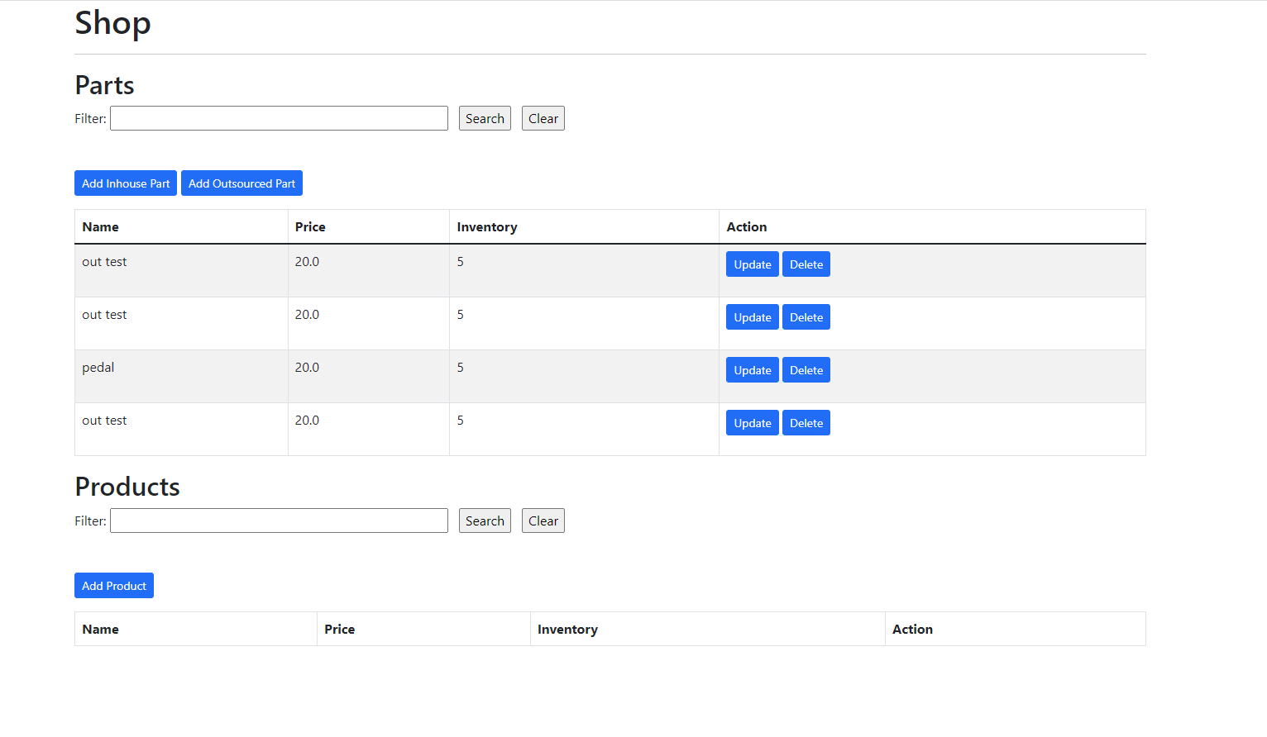*Figure 1. The main screen of the Shop Inventory Management System*

# Searching Parts

To search the parts list, type the name of the part in the part filter field, and press search. The list of parts should be filtered to only list parts with those characters contained in their name. To reset the list with all the parts, press clear.

# Adding Parts

To add an Inhouse Part, press on the Add Inhouse Part button. The detail screen is shown below:

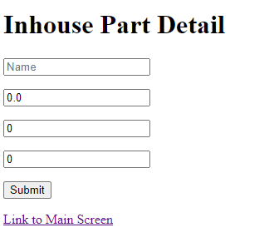

*Figure 2. The Inhouse Part Detail Screen*

The top field saves the name, the second the price, the third the number of items in stock, and the fourth the machine id. Press Submit to add a new part. When entering invalid information, error messages appear below the field.

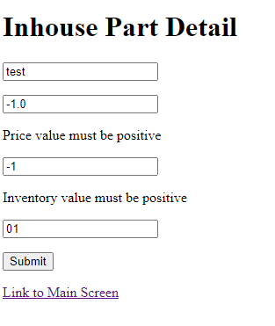

*Figure 3. The Inhouse Part Detail Screen with error messages.*

To add an Outsourced Part, press on the Add Outsourced Part button. The detail screen is shown below:

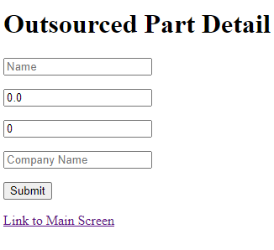

*Figure 4. The Outsourced Part Detail Screen*

The top field saves the name, the second the price, the third the number of items in stock, and the fourth the company name. Press Submit to add a new part. When entering invalid information, error messages appear below the field.

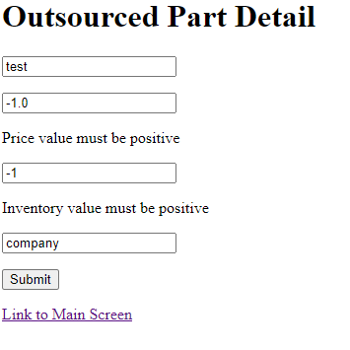

*Figure 5. The Outsourced Part Detail Screen with error messages*

# Updating Parts

To update a part, click on the Update button next to the part on the main screen list. The detail screen which is appropriate for the part (Inhouse or Outsourced) will populate with the part’s data. Make the desired modifications. When entering invalid information, error messages appear below the field. When you are ready to save your changes, press Submit.

To build more parts, update the inventory of the part and make it higher.

# Deleting Parts

To delete parts, press on the Delete button next to the part on the main screen. You cannot delete a part used in a product- however, you can set its number of parts in stock to 0.

# Searching Products

To search the products list, type the name of the part in the part filter field, and press search. The list of products should be filtered to only list products with those characters contained in their name. To reset the list with all the products, press clear.

# Adding Products

To add a Product, press on the Add Product button. The detail screen is shown below:

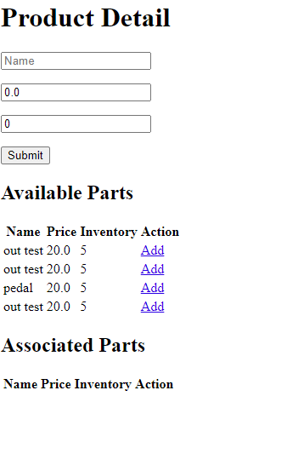

*Figure 6. The Product Detail Screen.*

Enter the name and price of the product and press submit to save. This will return you to the main screen, and the product will be added to the product list. When entering invalid information, error messages appear below the fields in a list after saving. Since this is a new product, with no parts attached, if you enter a number in stock, it will reset that number to 0.

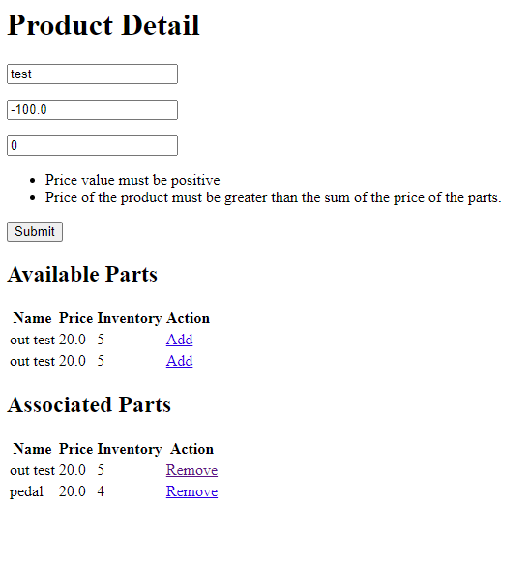

*Figure 7. The Product Detail Screen with error messages.*

# Updating Products

To update a product, click on the Update button next to the product on the main screen list. The product detail screen will populate with the part’s data.

1. Update this product by adding parts, clicking on the add button. You can only add one copy of a part. If you need to add two of the same parts, go back to the part screen, and make a “two parts” part and add it once.
2. Type in the number in stock and save.

When you save, it will remove the parts you used to build the new products from a part’s available inventory count. For example, if the number of products in stock is four, it will decrement the number of parts in stock for all the associated parts by four.

Make the desired modifications. When entering invalid information, error messages appear below the field. When you are ready to save your changes, and press submit to save. When entering invalid information, error messages appear below the fields in a list after saving.

Adding/Removing Parts to/from a product alone does not impact the inventory count of the parts as the previously specified product is already complete and on the shelves. You still must increase the inventory count of the product and save when ready to begin assembly of the modified product, and thus reducing the stock counts of the parts associated with it.

To build more products, update the inventory of the products. This will remove from the parts associated with the product the number of parts equal to the current inventory of products minus the prior inventory of products. In other words, it will remove only the number of parts used to make the additional products.

Lowering number of products in stock does not increase the number of parts. The products aren’t disassembled and used for inventory- instead this reflects the products have been sold.

# Delete Products

To delete products, press on the Delete button next to the product on the main screen. This will not affect the number of parts in any way.

# Full Stack Java Developers Wanted!

Our system is functional, be we are aware it can be improved as well as customized for individual clients. If you have ideas to make the system better for your own satisfaction, please feel free to make some changes! However, do make sure the system fulfills our current and future requirements.